|  |
| --- |
|  |
| **Geometry Unit 6** *Two and Three Dimensional Figures* |
|  |

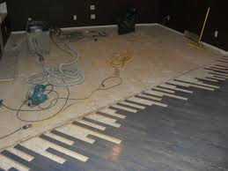

# Sample Problem:

Your parents have decided to remodel their living room. They want to change the carpet to hardwood floors. Sketch a picture of your living room and use a tape measure to find the dimensions. Boxes of hardwood will cover 30 square feet. How many boxes of hardwood will you need to buy? Explain.

|  |
| --- |
|  |
| Additional Support:  * Check the teacher web page and Canvas page for notes, activities, and assignments. * Search the topic on the web. We recommend using Khan Academy. * Attend tutorials.   Continued on next page 🡪 |

Our Learning Goals:

We will…

* find the area of parallelograms, triangles, trapezoids, rhombi, kites, and regular polygons.
* use trigonometry to find the area of regular polygons and triangles.
* find the surface area of prisms, cylinders, pyramids, cones, and spheres.
* find the volume of prisms, cylinders, pyramids, cones, and spheres.

|  |
| --- |
|  |
| Why do we study this?   * We use area and surface area to estimate how much flooring, wallpaper, or paint to purchase for home renovation projects. * We use volume when we measure liquids for recipes or when we fuel our cars. Choosing to buy soda in12 oz. cans or 20 oz. bottles also requires an understanding of volume. |
|  |

How we will show what we have learned…

|  |  |
| --- | --- |
| Formative Assessments | Summative Assessments |
| Ongoing formative assessments during lesson & homework activities will help in monitoring learning and providing feedback for students. | Summative assessments to measure learning at the end of concepts will include the following:   * Test: Area * Unit 5 Exam (district wide) |

|  |
| --- |
| **Geometry Unit 6 (Continued)** *Probability* |
|  |

Our Learning Goals:

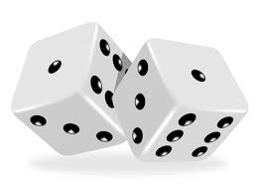

# Sample Problem:

Alexander is playing a game where he must roll 2 dice. If Alexander rolls a 7 or more, he wins the game. What is the probability of Alexander winning the game?

|  |
| --- |
|  |
| Additional Support:  * Check the teacher web page and Canvas page for notes, activities, and assignments. * Search the topic on the web. We recommend using Khan Academy. * Attend tutorials. |

We will…

* calculate experimental and theoretical probabilities.
* use segment and area models to find the probabilities of events.
* use permutations and combinations to solve problems.
* identify independent and dependent events, as well as find compound probabilities.

|  |
| --- |
|  |
| Why do we study this?   * In our lives we are always exposed to risks. Probability theory gives us one way to think about these risks. * Medical researchers use statistics and probability to establish the likelihood that a drug or treatment will be effective. Social scientists use statistics to make generalizations about people’s behavior. Market researchers use statistical probabilities to help sell products. |
|  |

How we will show what we have learned…

|  |  |
| --- | --- |
| Formative Assessments | Summative Assessments |
| Ongoing formative assessments during lesson & homework activities will help in monitoring learning and providing feedback for students. | Summative assessments to measure learning at the end of concepts will include the following:   * Test: Probability * Final Exam (district wide) |